3/5/2025
Course Title: Data Structure and Algorithms-II Lab
Course Code: CSE 2202
Prepared by:
Md. Ehasan Mahmud
Roll: 202122104026
Department: Computer Science and Engineering
Submitted to:
Dr. Sujan Chandra Roy
Lecturer
Department of Computer Science and Engineering
Kishoreganj University.

Assignment-03
Demonstrate the 0-1 Knapsack problem solution:
Code:
#include <bits/stdc++.h>
using namespace std;
#include <ext/pb_ds/assoc_container.hpp>
using namespace __gnu_pbds;
using ll=long long;
using ull=unsigned long long;
using ld=long double;
const ll MOD=998244353;
const ll M=200005;
template<typename T>
using indexed_set=tree<T,null_type,less<T>,rb_tree_tag,tree_order_statistics_node_update>;
ll calculateMaxValue(vector<ll>&weights,vector<ll>&values,ll capacity)
{
ll numItems=values.size();
vector<ll>dynamicProgramming(capacity+1,0);
for(ll i=0; i<numItems; i++)
{
for(ll j=capacity; j>=weights[i]; j--)
{
dynamicProgramming[j]=max(dynamicProgramming[j],values[i]+dynamicProgramming[j-weights[i]]);
}
}
return dynamicProgramming[capacity];
}
void executeSolution()
{
vector<ll>weights= {2,3,4,5};
vector<ll>values= {3,4,5,6};
ll maxCapacity=5;
ll result=calculateMaxValue(weights,values,maxCapacity);
cout<<"The maximum value achievable is: "<<result<<endl;
}
int main()
{
ios_base::sync_with_stdio(false);
cin.tie(0);
cout.tie(0);
executeSolution();
return 0;
}
Output:
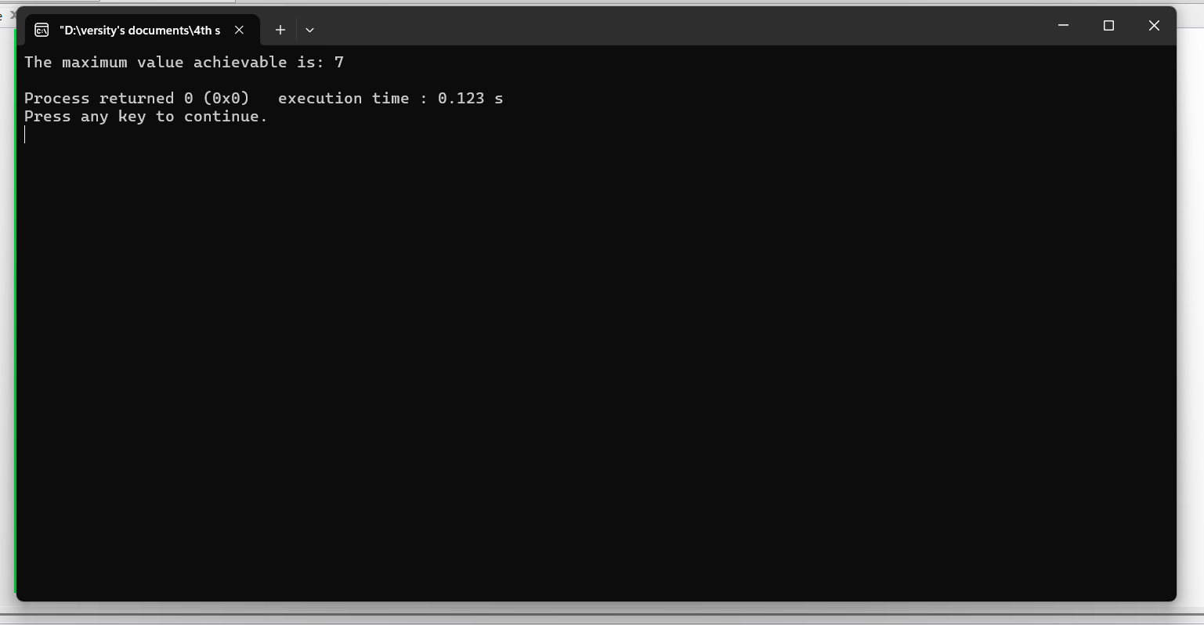

Demonstrate N-Queens problem using Backtracking:
Code:
#include <bits/stdc++.h>
using namespace std;
#include <ext/pb_ds/assoc_container.hpp>
using namespace __gnu_pbds;
using ll=long long;
using ull=unsigned long long;
using ld=long double;
const ll MOD=998244353;
const ll MAX_SIZE=200005;
template<typename T>
using ordered_set=tree<T,null_type,less<T>,rb_tree_tag,tree_order_statistics_node_update>;
bool canPlaceQueen(ll n,vector<vector<ll>>& grid,ll col)
{
if(col>=n)return true;
for(ll row=0; row<n; row++)
{
bool isValid=true;
for(ll i=0; i<col; i++)if(grid[row][i])isValid=false;
for(ll i=col,j=row; i>=0&&j>=0; i--,j--)if(grid[j][i])isValid=false;
for(ll i=col,j=row; i>=0&&j<n; i--,j++)if(grid[j][i])isValid=false;
if(isValid)
{
grid[row][col]=1;
if(canPlaceQueen(n,grid,col+1))return true;
grid[row][col]=0;
}
}
return false;
}
void solveNQueens()
{
ll n=6;
vector<vector<ll>>grid(n,vector<ll>(n,0));
if(!canPlaceQueen(n,grid,0))
{
cout<<"No valid configuration found\n";
return;
}
for(ll i=0; i<n; i++)
{
for(ll j=0; j<n; j++)cout<<grid[i][j]<<" ";
cout<<endl;
}
}
int main()
{
ios_base::sync_with_stdio(false);
cin.tie(nullptr);
cout.tie(nullptr);
solveNQueens();
return 0;
}
Output:
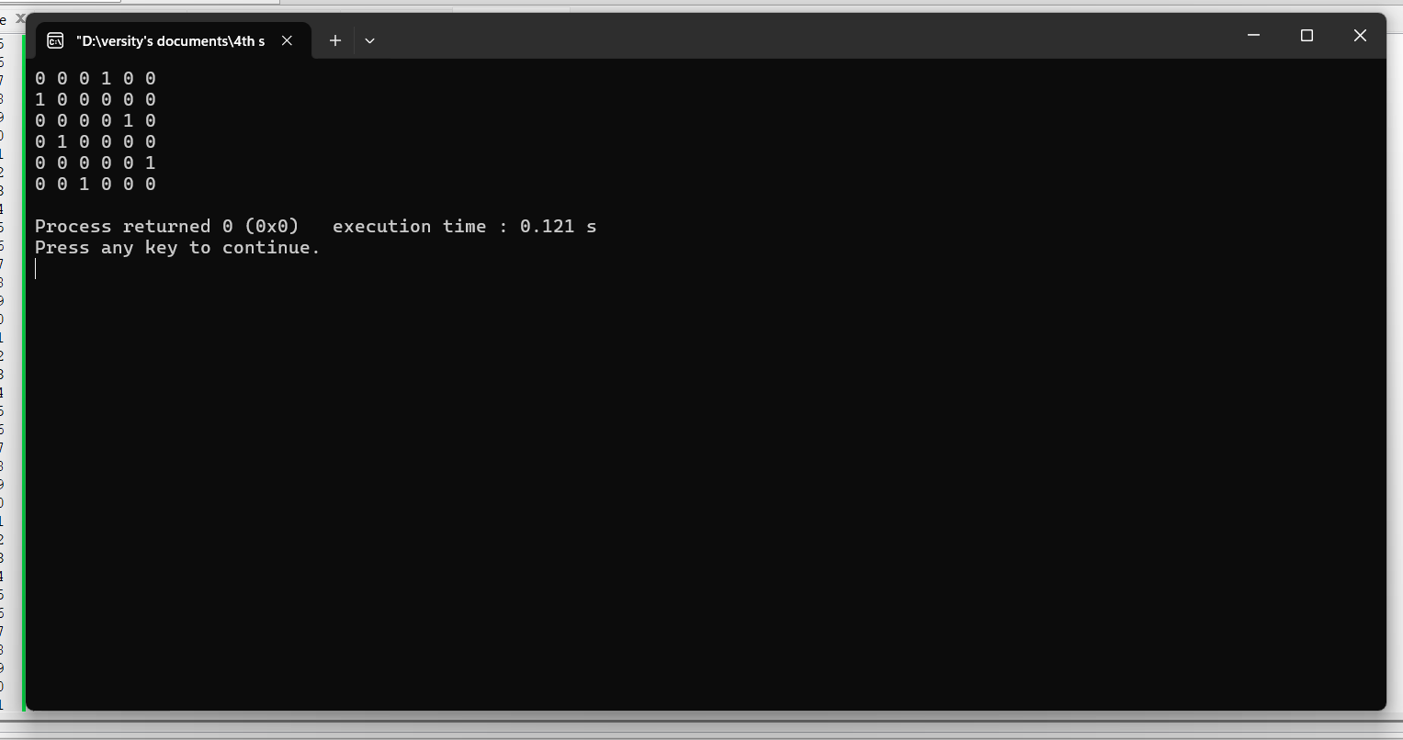

End

